Parent request for Therapy services at School.
At Herne Hill Primary School, we understand the important role that NDIS funded services can play in supporting students’ learning, communication, wellbeing and development. Wherever possible, we will work with families and providers to support students accessing these services during the school day.
Recent changes to Department of Education policy mean that schools are now required to follow a formal process when considering requests for external therapists and providers to work on school grounds. With the increasing number of requests, we are also finding that available spaces and school operations can sometimes make it difficult to accommodate all sessions during the school day.
While schools have responsibilities under the Disability Discrimination Act 1992 and the Disability Standards for Education 2005, schools must also ensure that all students continue to have access to learning and that school operations can run safely and effectively for everyone.
When considering requests for external providers to attend school, we need to take a number of things into account, including:
- the student’s wellbeing and learning needs
- the impact on the student’s access to classroom learning
- goals identified within student plans
- the impact on other students and staff
- the timing and length of sessions
- whether the service could reasonably occur outside school hours or through existing Department programs
- available school spaces and resources
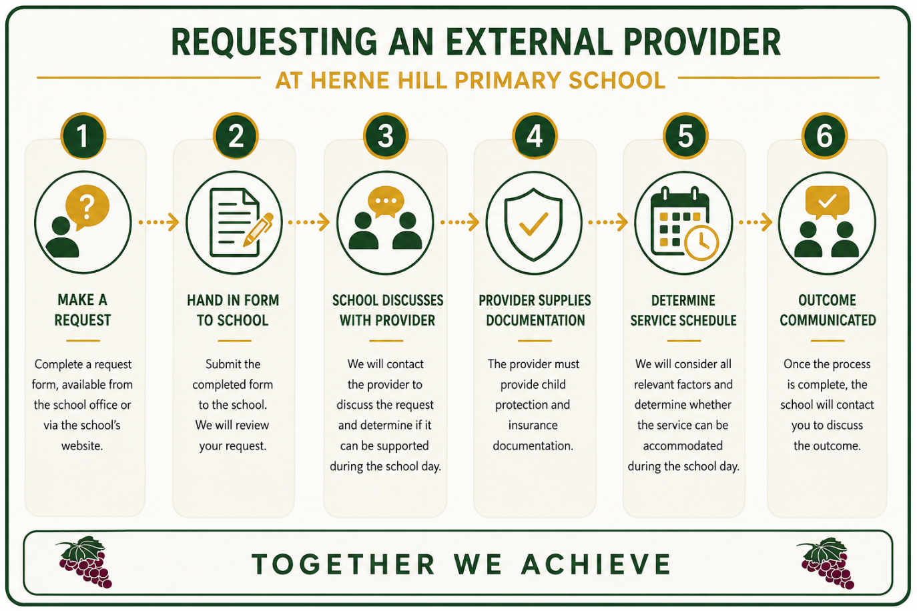
- the school’s duty of care to all students and staff
In some situations, requests may not be able to be approved if the sessions significantly disrupt learning, impact other students or staff, or can reasonably take place outside school hours.
We appreciate families’ understanding as we work to balance the needs of individual students with the learning and wellbeing of the wider school community.
If you would like to request for an external provider to attend school to provide a therapy session during the school day, the first step is to complete a request form, available from the school office or via the school’s website. Once the form has been submitted to the school, we will contact the provider to discuss the request and determine whether it can be accommodated during the school day. Providers are also required to supply documentation relating to child protection and insurance requirements.
Once this process has been completed, the school will contact you to discuss the outcome.
If you have any questions, please contact Chris Smith or Amy Millar.

